English schools athletics championships 2025
A very successful weekend for the West Yorkshire Schools team, earning 8 medals and finishing 5th as a ‘B’ county, a massive improvement on previous years.
There were many other fantastic performances and numerous new personal bests set.

Fifth overall as a B county.
Jun Boys 2nd
Inter Boys 4th
Sen Boys 3rd
Jun Girls 3rd
Inter Girls 5th
Sen Girls 14th

All the West Yorkshire Schools athletes have done themselves and us very proud.
Our finalists:
Grace Goode JG 200m 2nd
Ben Jackson JB 200m 6th
Maya Schofield IG 800m 3rd
Isabella Tutt IG 1500m 6th
Ethan Hegarty IB 200m 3rd
Eddie Joseph IB 200m 8th
Maisey Bellwood SG 1500m 9th
Rafferty Mirfin SB 1500m 1st
Cole McAndrew SB 1500m 8th
Archie Budding SB Steeplechase 8th
Maisey Bellwood 1500m 9th
Abigail Kinston IG Shot 9th
Romy Fagan JG HJ 2nd
Cruz Collins JB TJ 2nd
Josh Akintolu IB HJ 7th
Matejus Varnelis IB Discus 7th
Mallerie Samuel SG PV 6th
Ami Dawodu SB SP 2nd
Arthur Reilly SB PV 1st
Daniel Akintolu SB LJ 7th

Final medals won:
Gold:
Rafferty - Senior Boys 800m (continuing his winning streak from last year)
Arthur - Senior Boys Pole Vault
Silver:
Amir - Senior Boys Shot Putt
Grace - Junior Girls 200m
Romy - Junior Girls High Jump
Cruz - Junior Boys Triple Jump
Bronze:
Ethan - Inter Boys 200m
Maya - Inter Girls 800m

Also big congratulations to Ethan who will represent England at the schools international next weekend in Derby, we may also have Maya who is currently a reserve.

A big thank you to my fellow team managers for their hard work this weekend.
We all (athletes and team managers) feel incredibly proud of ALL our athletes, 5th in 2025; let us go for 1st 2026!

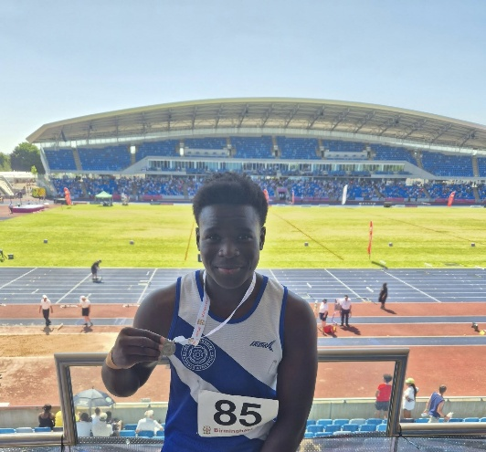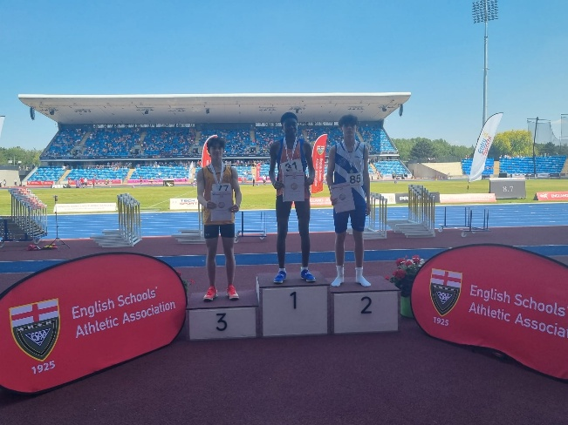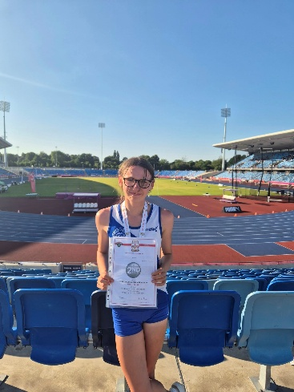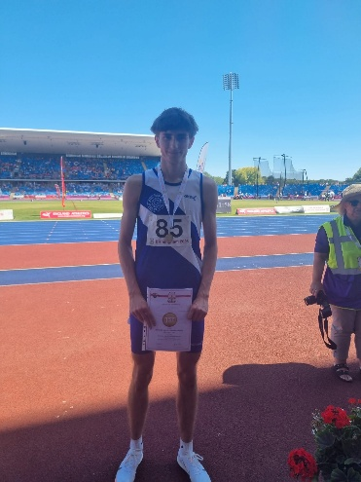

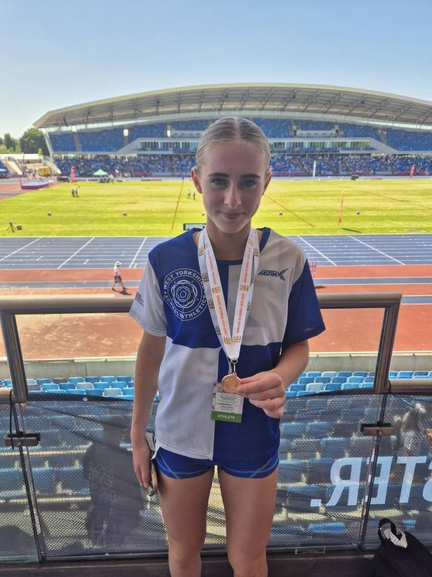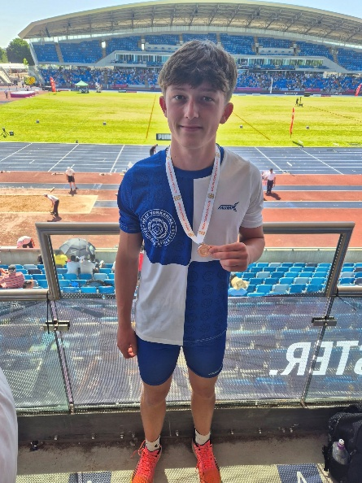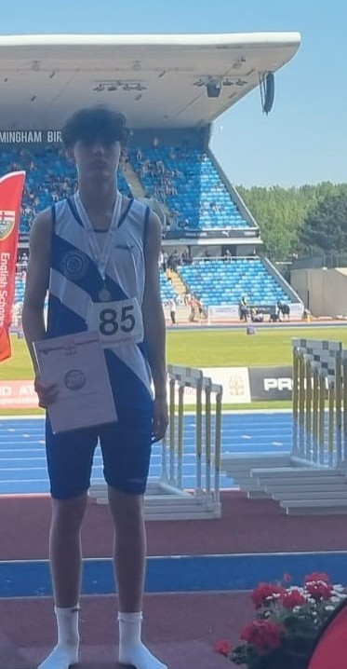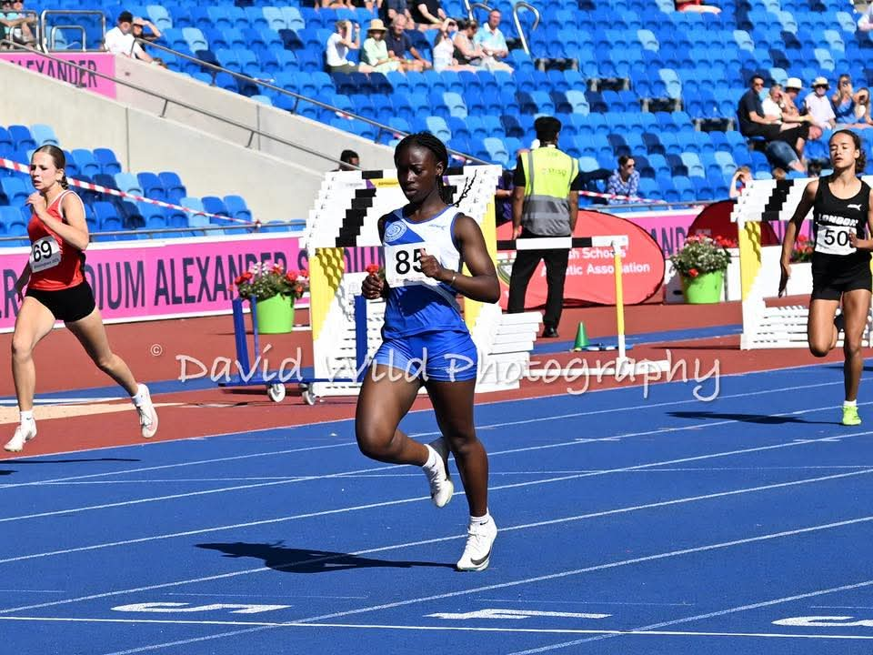

See link attached to all of David Wilds pics from the weekend. A big thankyou to David for not only his pics but also his participation in the Champions parade. Pictured below with Alan Pascoe and Richard Carter (Richard is an old friend of mine from our World Cross Country days and Univ)

https://www.facebook.com/groups/1438656489728353

