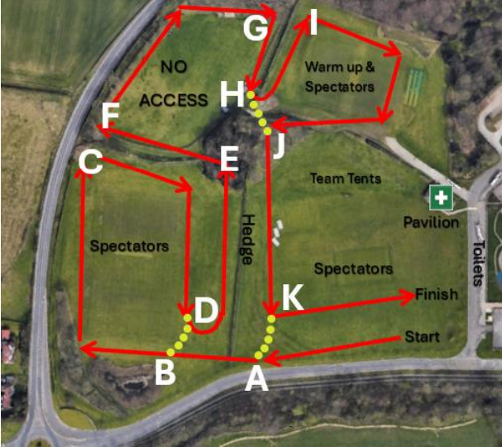

Race 1 Senior Girls Distance  Lap 1 Start-A,B,C,D,E,F,G,H,I,J,K 1440m  Lap 2 K,A,B,C,D,E,F,G,H,I,J K – Finish 1790m  3230m  Race 2 Senior Boys Distance  Lap 1 Start- A,B,C,D,E,F,G,H,I,J,K 1790m  Lap 2 K,A,B,C,D,E,F,G,H,I,J,K 1650m  Lap 3 K,A,B,C,D,E,F,G,H,I,J,K-finish 1790m  5230m  Race 3 & 4 Year 7 Girls & Boys Distance  Lap 1 Start-,A,B,C,D E,F,G,H,I,J,K, finish  1790m  Race 5 & 6 Junior Girls & Boys Distance  Lap 1 Start-A,B,C,D 650m  Lap 2 D,B,C,D,E F,G,H,I J,K-finish 1790m  2440m  Race 7 Intermediate Girls Distance  Lap 1 Start-A,B,C,D,E,F,G,H,J,K 1440m  Lap2 K,A,B,C,D,E,F,G,H,J,K-finish 1440m  2880m  Race Intermediate Boys Distance  Lap 1 Start-A,B,C,D 650m  Lap 2 D,B,C,D,E F,G,H,I J,K 1650m  Lap 3 K,A,B,C,D,E,F,G,H,I,J,K-finish 1790m  4090m | Race Intermediate Boys Distance  Lap 1 Start-A,B,C,D 650m  Lap 2 D,B,C,D,E F,G,H,I J,K 1650m  Lap 3 K,A,B,C,D,E,F,G,H,I,J,K-finish 1790m  4090m  Race Times  - Senior Girls -1pm  - Senior Boys- 1.20pm  - Year 7 Girls- 1.55pm  - Year 7 Boys- 2.05pm  - Junior Girls -2.15pm  - Junior Boys- 2.35pm  - Intermediate Girls- 2.55pm  - Intermediate Boys- 3.20pm  General Information  - Arrival from 12pm, not before  - No Dogs at GSAL  - Coffee van on site, by the pavilion  - Medical staff based at the pavilion  - Parking Instructions on arrival

